## **Presidio Day 15 ER Diagrams:**

Shopping Application : Smart Draw

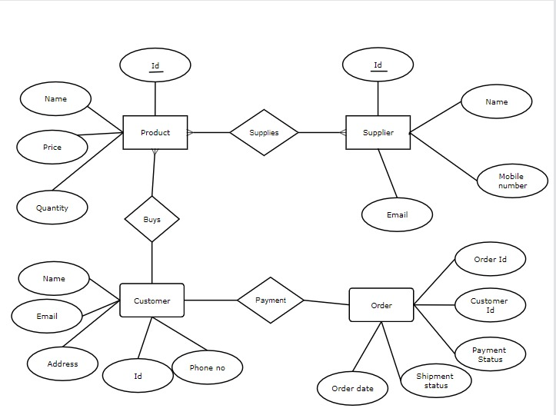

Video Rental application : Creately

